# File permissions in Linux

## Project description

In this assignment, there are some files in the project directory which have different kinds of permissions for read, write, and execution access. I have to make sure that all files have the right permissions and if they don’t use Linux commands to manage the permissions.

## Check file and directory details

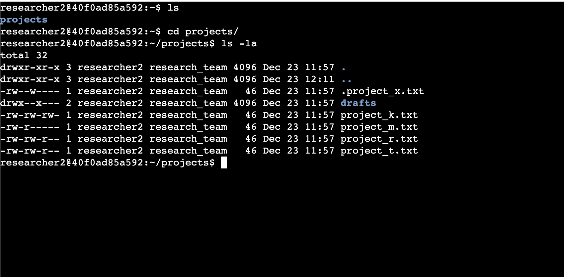

## Describe the permissions string

As can be seen in the previous screenshot from the project, there are different permissions for different user groups for different files. As an example, **project_k.txt** has read and write permissions for all user, group, and other.

## Change file permissions

The company does not allow the other group to have any write permissions on any of the projects. As can be seen, this group has write access to **project_k.txt** . Therefore, it is needed to remove this access.

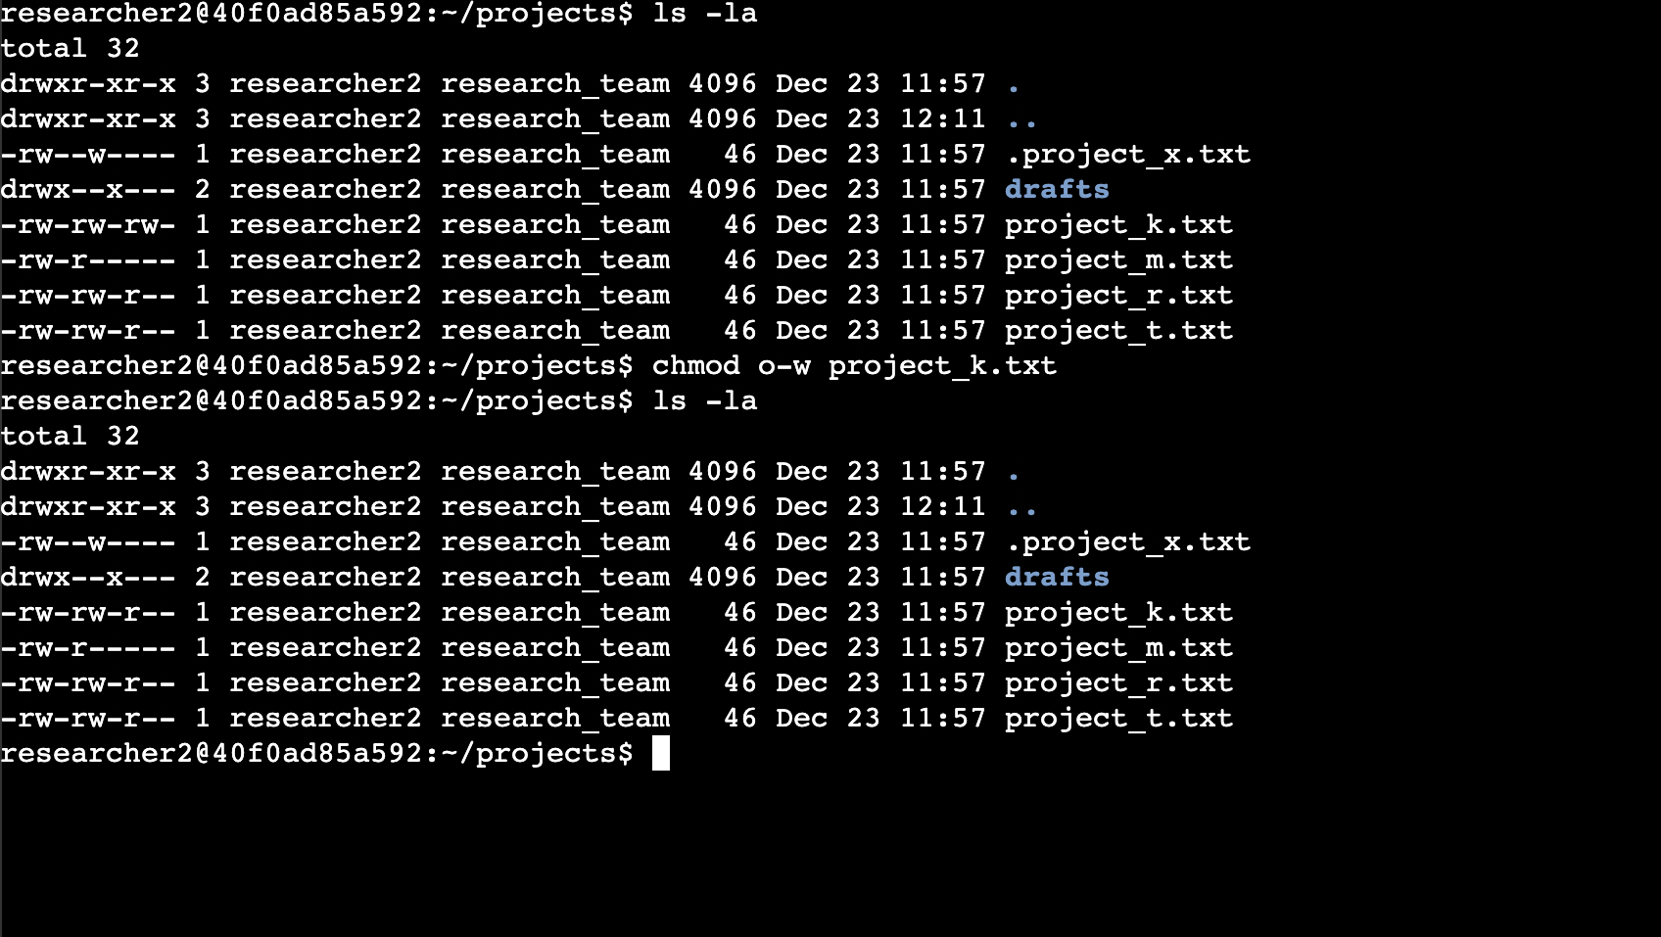

## Change file permissions on a hidden file

The research team has archived **.project_x.txt**, which is why it’s a hidden file. This file should not have write permissions for anyone, but the user and group should be able to read the file.

We use the following command to remove the write access from both user and group: chmod u-w .project_x.txt & chmod g-w .project_x.txt

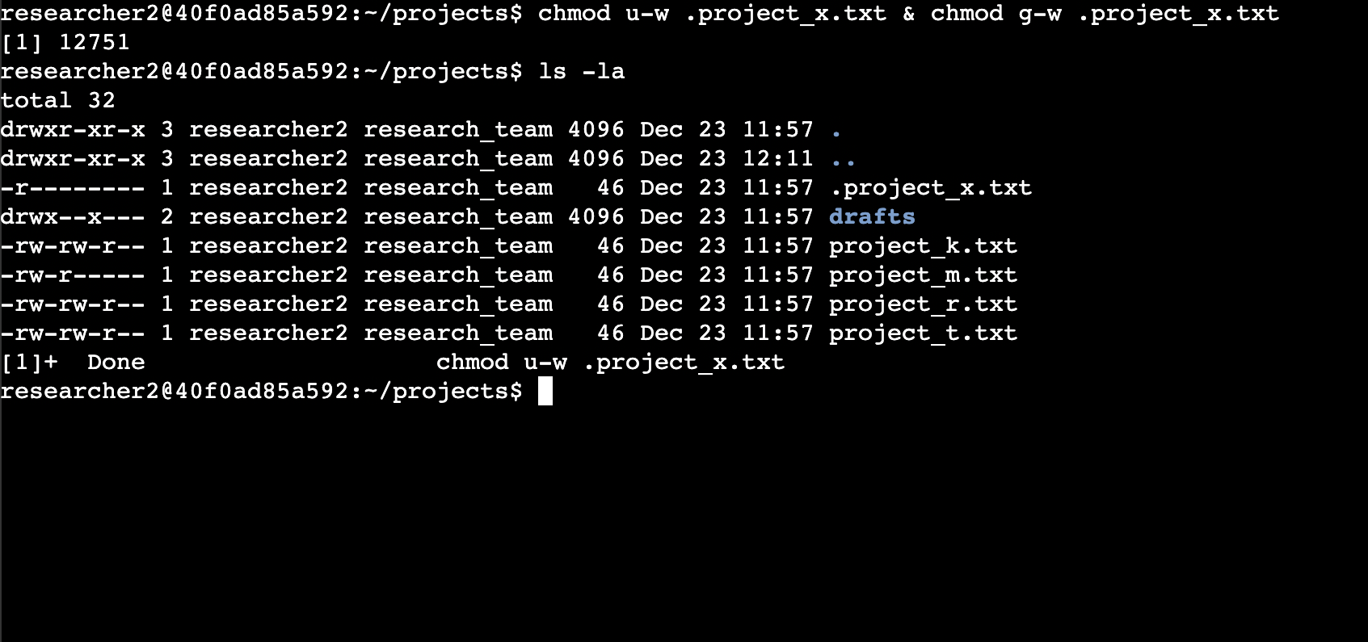

## Change directory permissions

The files and directories in the projects directory belong to the **researcher2** user. Only **researcher2** should be allowed to access the **drafts** directory and its contents.

We use the following command to make sure that only this user has the execute access to this directory: chmod g-x drafts/

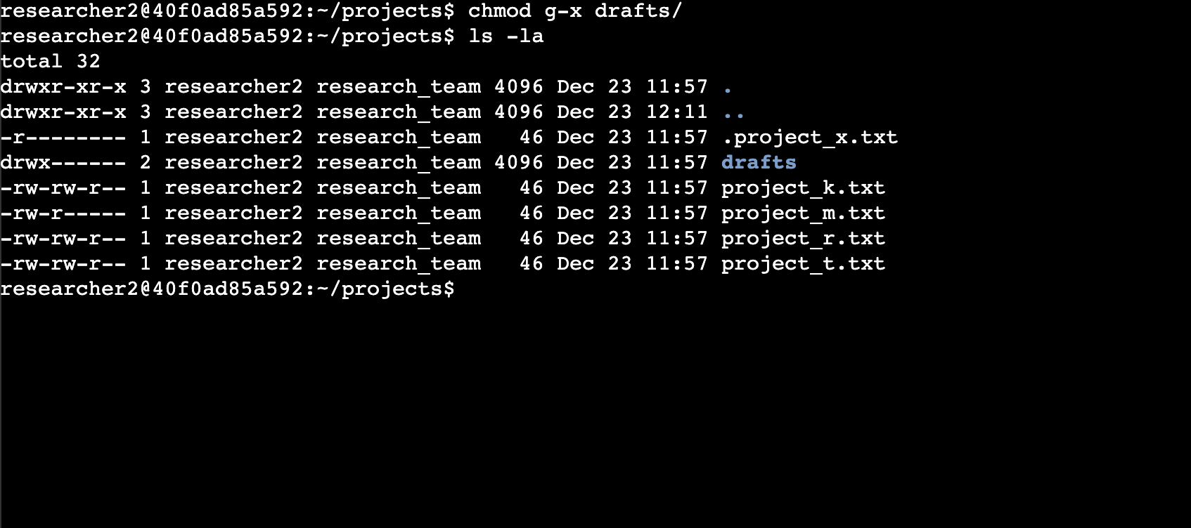

## Summary

In this assignment, I used different file permission management commands in Linux to manage the access of different user groups like user, group, and other to different files, hidden files, and directories.